# JS Applications Exam - Movies SPA

You are assigned to implement a **Web application** (SPA) using HTML5, JavaScript, AJAX, REST and JSON with cloud-based backend (Kinvey). Using libraries like **jQuery**, **Handlebars** and **Sammy** is allowed but is not obligatory. The app keeps **users** and **movies**. Guests should be able to **register** and **login**. Logged-in users should be able to view **all movies**, **create** **movies**, **buy tickets** for the movies, see **details** about a **movie** and **logout**. Logged-in users should also be able to **edit** or **delete** the movies **they have created**. There should also be a **section** where users can **see only the movies they have created**.

## Create a Kinvey REST Service

Register at **Kinvey.com** and create an application to keep your data in the cloud.

Create a collection called **movies**. Each **movie** has a title**,** description**,** imageURL**,** ticketsand genres **(array)**.

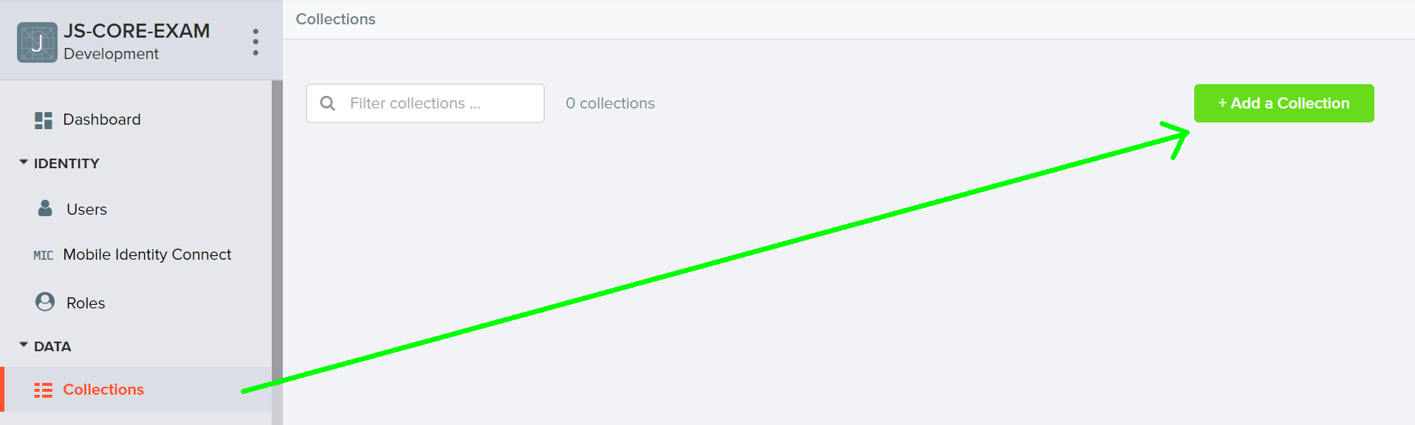

In order to be able to keep track of the **tickets** of each movie, you need to **allow all users to edit this collection**. So go to the **properties** of the collection:

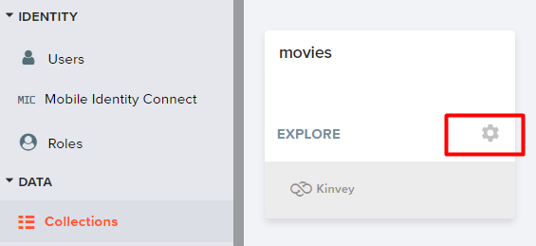

Then go to **permissions** and edit them to look like this:

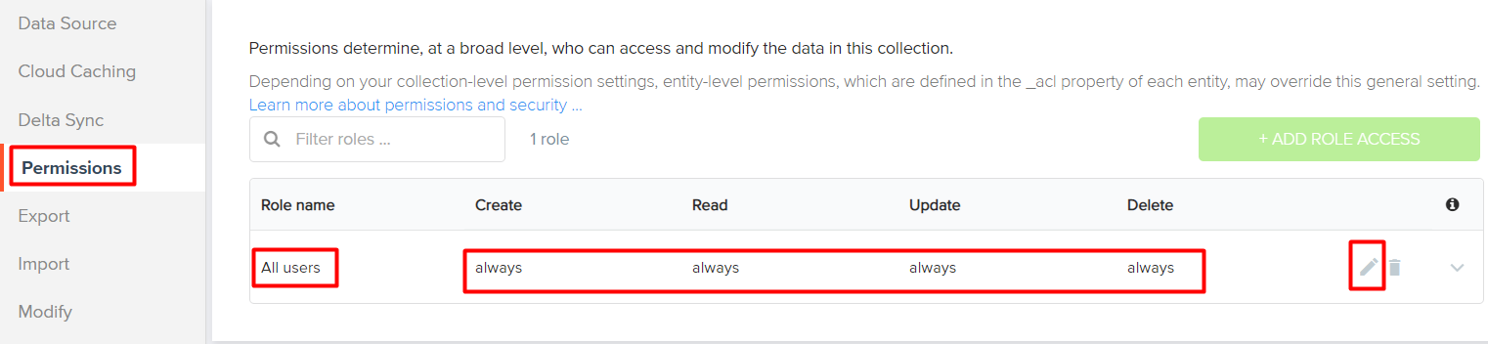

## Test the Kinvey REST Services

Using **Postman** or other HTTP client tool (you can use Kinvey’s built-in **API Console**), test the REST service endpoints:

### User Registration (Sign Up)

|  |  |
| --- | --- |
| **POST** [https://baas.kinvey.com/user/***app_id***](https://baas.kinvey.com/user/app_id/) | |
| **Request headers** | Authorization: Basic base64(app_id:app_secret)  Content-Type: application/json |
| **Request body** | {  "username": "testuser",  "password": "testuserpass890"  } |
| **Response**  **201 Created** | {  "_id": "59930c78a743e20c7d3fca77",  "username": "testuser",  "password": "testuserpass890"  } |
| **Error response**  **409 Conflict** | { "error": "UserAlreadyExists", "description": "This username is already taken. Please retry your request with a different username", "debug": "" } |
| **Error response**  **401 Unauthorized** | { "error": "InvalidCredentials", "description": "Invalid credentials. Please retry your request with correct credentials", "debug": "" } |

The request needs "Basic" authentication. Use the Kinvey AppKey and Kinvey AppSecret as credentials.

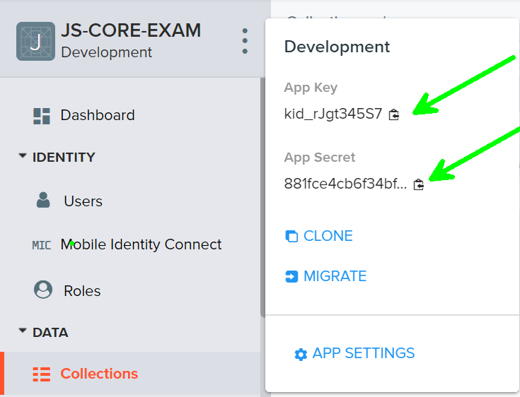

### User Login

|  |  |
| --- | --- |
| **POST** [**https://baas.kinvey.com/user/*app_id*/login**](https://baas.kinvey.com/user/app_id/login) | |
| **Request headers** | Authorization: Basic base64(app_id:app_secret)  Content-Type: application/json |
| **Request body** | {  "username": "testuser",  "password": "testuserpass890"  } |
| **Response**  **200 OK** | {  "_id": "59930c78a743e20c7d3fca77",  "username": "testuser"  "_kmd": {  "authtoken": "8e6471bc-3712-4cfb-b92e-50e62a0c80….Duj5fHdM /7XHIe6KdY="  …  },  …  } |
| **Error response**  **401 Unauthorized** | { "error": "InvalidCredentials", "description": "Invalid credentials. Please retry your request with correct credentials", "debug": "" } |

Successful login returns an **authtoken** which is later used to authenticate the CRUD operations.

### User Logout

|  |  |
| --- | --- |
| **POST** [https://baas.kinvey.com/user/***app_id***/_logout](https://baas.kinvey.com/user/app_id/_logout) | |
| **Request headers** | Authorization: Kinvey authtoken |
| **Response**  **204 No Content** |  |
| **Error response**  **401 Unauthorized** | { "error": "InvalidCredentials", "description": "Invalid credentials. Please retry your request with correct credentials", "debug": "" } |

To logout, you need to provide the **authtoken** given by login/register as "**Kinvey**" authorization header.

### List All Movies

|  |  |
| --- | --- |
| **GET** [https://baas.kinvey.com/appdata/***app_id***/movies](https://baas.kinvey.com/appdata/app_id/movies)?query={}&sort={} | |
| **Request headers** | Authorization: Kinvey authtoken |
| **Response**  **200 OK** | [  {  "_id": "5c9234b6cad7d87d9f873b90",  "title": "Us (2019)",  "imageUrl":"https://m.media-amazon.com/images/M/MV5BZTliNWJhM2YtNDc1MC00YTk1LWE2MGYtZmE4M2Y5ODdlNzQzXkEyXkFqcGdeQXVyMzY0MTE3NzU@._V1_UX140_CR0,0,140,209_AL_.jpg",  "description": "A family's serenity turns to chaos when a group of doppelgängers begins to terrorize them.",  "genres": [  "Horror,Triller"  ],  "tickets": "52",  "_acl": {  "creator": "5c91f497dc781901a7e5745c"  },  "_kmd": {  "lmt": "2019-03-21T08:31:38.656Z",  "ect": "2019-03-20T12:40:22.352Z"  }  },  {  "_id": "5c92353231f05528ddabc64d",  "title": "Triple Threat (2019)",  "imageUrl": "https://m.media-amazon.com/images/M/MV5BYTY1MjRhYmYtZDg4Yy00ZWRiLWIwYzktZThkY2E0YjZlNjgxXkEyXkFqcGdeQXVyMTc3MjY3NTY@._V1_UY209_CR0,0,140,209_AL_.jpg",  "description": "A hit contract is taken out on a billionaires daughter intent on bringing down a major crime syndicate. A down and out team of mercenaries must take on a group of professional assassins and stop them before they kill their target.",  "genres": [  "Action",  "Thriller"  ],  "tickets": "22",  "_acl": {  "creator": "5c9234f4dc781901a7e87ce9"  },  "_kmd": {  "lmt": "2019-03-20T13:47:12.419Z",  "ect": "2019-03-20T12:42:26.360Z"  }  }  ] |
| **Error response**  **401 Unauthorized** | { "error": "InvalidCredentials", "description": "Invalid credentials. Please retry your request with correct credentials", "debug": "" } |

### Create Movie

|  |  |
| --- | --- |
| **POST** [https://baas.kinvey.com/appdata/***app_id***/movies](https://baas.kinvey.com/appdata/app_id/movies) | |
| **Request headers** | Authorization: Kinvey authtoken  Content-Type: application/json |
| **Request body** | {"title": "test movie", "description": "test movie description", "imageUrl": "https://m.media-amazon.com/images/M/MV5BMTQzOTUyODMyOV5BMl5BanBnXkFtZTcwNzY2MzU1MQ@@._V1_.jpg", "genres": ["Thriller", "Drama"], "tickets": 50} |
| **Response**  **201 Created** | {  "title": "test movie",  "description": "test movie desciption",  "imageUrl":"https://m.media-amazon.com/images/M/MV5BMTQzOTUyODMyOV5BMl5BanBnXkFtZTcwNzY2MzU1MQ@@._V1_.jpg",  "genres": [  "Thriller",  "Drama"  ],  "tickets": 50,  "_acl": {  "creator": "5c91f497dc781901a7e5745c"  },  "_kmd": {  "lmt": "2019-03-21T08:57:28.073Z",  "ect": "2019-03-21T08:57:28.073Z"  },  "_id": "5c9351f8b66da201acf6ffb8"  } |
| **Error response**  **401 Unauthorized** | { "error": "InvalidCredentials", "description": "Invalid credentials. Please retry your request with correct credentials", "debug": "" } |

### Edit Movie

|  |  |
| --- | --- |
| **PUT** [https://baas.kinvey.com/appdata/***app_id***/movies/***movie_id***](https://baas.kinvey.com/appdata/app_id/movies/movie_id) | |
| **Request headers** | Authorization: Kinvey authtoken  Content-Type: application/json |
| **Request body** | {  "title": "test movie",  "description": "test movie desciption",  "imageUrl":"https://m.media-amazon.com/images/M/MV5BMTQzOTUyODMyOV5BMl5BanBnXkFtZTcwNzY2MzU1MQ@@._V1_.jpg",  "genres": [  "Thriller",  "Drama"  ],  "tickets": 49  } |
| **Response**  **200 Ok** | {  "title": "test movie",  "description": "test movie desciption",  "imageUrl":"https://m.media-amazon.com/images/M/MV5BMTQzOTUyODMyOV5BMl5BanBnXkFtZTcwNzY2MzU1MQ@@._V1_.jpg",  "genres": [  "Thriller",  "Drama"  ],  "tickets": 49,  "_id": "5c9351f8b66da201acf6ffb8",  "_acl": {  "creator": "5c91f497dc781901a7e5745c"  },  "_kmd": {  "lmt": "2019-03-21T09:02:01.340Z",  "ect": "2019-03-21T08:57:28.073Z"  }  } |
| **Error response**  **401 Unauthorized** | { "error": "InvalidCredentials", "description": "Invalid credentials. Please retry your request with correct credentials", "debug": "" } |

### Delete Movie

|  |  |
| --- | --- |
| **DELETE** [https://baas.kinvey.com/appdata/*app_id*/movies/**movie*_id***](https://baas.kinvey.com/appdata/app_id/movies/movie_id) | |
| **Request headers** | Authorization: Kinvey authtoken |
| **Response**  **200 OK** | {  "count": 1  } |
| **Error response**  **404 Not Found** | { "error": "EntityNotFound", "description": "This entity not found in the collection", "debug": "" } |
| **Error response**  **401 Unauthorized** | { "error": "InvalidCredentials", "description": "Invalid credentials. Please retry your request with correct credentials", "debug": "" } |

### Buy Tickets

|  |  |
| --- | --- |
| **PUT** [https://baas.kinvey.com/appdata/*app_id*/movies/**movie*_id***](https://baas.kinvey.com/appdata/app_id/movies/movie_id) | |
| **Request headers** | Authorization: Kinvey authtoken  Content-Type: application/json |
| **Request body** | {  "title": "test movie",  "description": "test movie description",  "imageUrl": "https://m.media-amazon.com/images/M/MV5BMTQzOTUyODMyOV5BMl5BanBnXkFtZTcwNzY2MzU1MQ@@._V1_.jpg",  "genres": ["Thriller", "Drama"],  "tickets": 49  } |
| **Response**  **200 Ok** | {  "title": "test movie",  "description": "test movie desciption",  "imageUrl":"https://m.media-amazon.com/images/M/MV5BMTQzOTUyODMyOV5BMl5BanBnXkFtZTcwNzY2MzU1MQ@@._V1_.jpg",  "genres": [  "Thriller",  "Drama"  ],  "tickets": 49,  "_id": "5c9351f8b66da201acf6ffb8",  "_acl": {  "creator": "5c91f497dc781901a7e5745c"  },  "_kmd": {  "lmt": "2019-03-21T09:02:01.340Z",  "ect": "2019-03-21T08:57:28.073Z"  }  } |
| **Error response**  **401 Unauthorized** | { "error": "InvalidCredentials", "description": "Invalid credentials. Please retry your request with correct credentials", "debug": "" } |

### My Movies

|  |  |  |
| --- | --- | --- |
| **GET** [https://baas.kinvey.com/appdata/***app_id***/movies?query={"_acl.creator":"${***user_id***}"}](https://baas.kinvey.com/appdata/app_id/movies?query=%7b%22_acl.creator%22:%22$%7buser_id%7d%22%7d) | | |
| **Request headers** | Authorization: Kinvey authtoken | |
| **Response**  **200 OK** | [  {  "_id": "5c9234b6cad7d87d9f873b90",  "title": "Us (2019)",  "imageUrl": "https://m.media-amazon.com/images/M/MV5BZTliNWJhM2YtNDc1MC00YTk1LWE2MGYtZmE4M2Y5ODdlNzQzXkEyXkFqcGdeQXVyMzY0MTE3NzU@._V1_UX140_CR0,0,140,209_AL_.jpg",  "description": "A family's serenity turns to chaos when a group of doppelgängers begins to terrorize them.",  "genres": [  "Horror,Triller"  ],  "tickets": "52",  "_acl": {  "creator": "5c91f497dc781901a7e5745c"  },  "_kmd": {  "lmt": "2019-03-21T08:31:38.656Z",  "ect": "2019-03-20T12:40:22.352Z"  }  }  … ] | |
| **Error response**  **401 Unauthorized** | { "error": "InvalidCredentials", "description": "Invalid credentials. Please retry your request with correct credentials", "debug": "" } |

## Movies - HTML and CSS

You have been given the web design of the application as **HTML** + **CSS** files.

* Initially all views and forms are shown by the HTML. Your application may **hide**/**show elements** by CSS (display: none) or **delete**/**reattach** from and to the DOM all unneeded elements, or just display the views it needs to display.
* You may render the views/forms/components with **jQuery** or **Handlebars**.

**Important**: Don’t change the elements’ **class names** and **ids**. Don’t rename form fields/link names/ids. You are **allowed** to add **data attributes** to any elements. You may modify href **attributes** of links and add action**/**method **attributes** to **forms**, to allow the use of a routing library.

## Movies - Client-Side Web Application

**Design** and **implement** a client-side front-end app (SPA) for managing **movies**. Implement the functionality described below.

### Notifications (5 pts)

The application should notify the users about the result of their actions.

* In case of successful action an **informational (green) notification message** should be shown, which disappears automatically after 3 seconds or manually when the user clicks it.



* In case of **error**, an **error notification message** (red) should be shown which disappears on user click.



* During the AJAX calls a **loading notification message (blue)** should be shown. It should disappear automatically as soon as the AJAX call is completed.



* **NOTE: You get all 5 point if the notifications contain the right messages.**

### Navigation Bar (5 pts)

Navigation links should correctly change the current page (view). **The navbar should be displayed in every view!**

* Clicking on the links in the **NavBar** should display the view behind the link (views are represented as sections in the HTML code).
* Your application may **hide**/**show elements** by CSS (display: none) or **delete**/**reattach** from and to the DOM all unneeded elements, or just display the views it needs to display.
* The links [Cinema], [Add Movie], [My Movies], [Logout], and the user caption   
  "Welcome, {username}!" should be visible **only** for logged-in users.



* Anonymous users have access only to the following links: [Home], [Login]and[Register].



### Home Screen (5 pts)

The initial page (view) should display:

* **NavBar** with the following links [Home], [Login], [Register]
* The **image** from the resources (background.jpg)
* The **Footer**

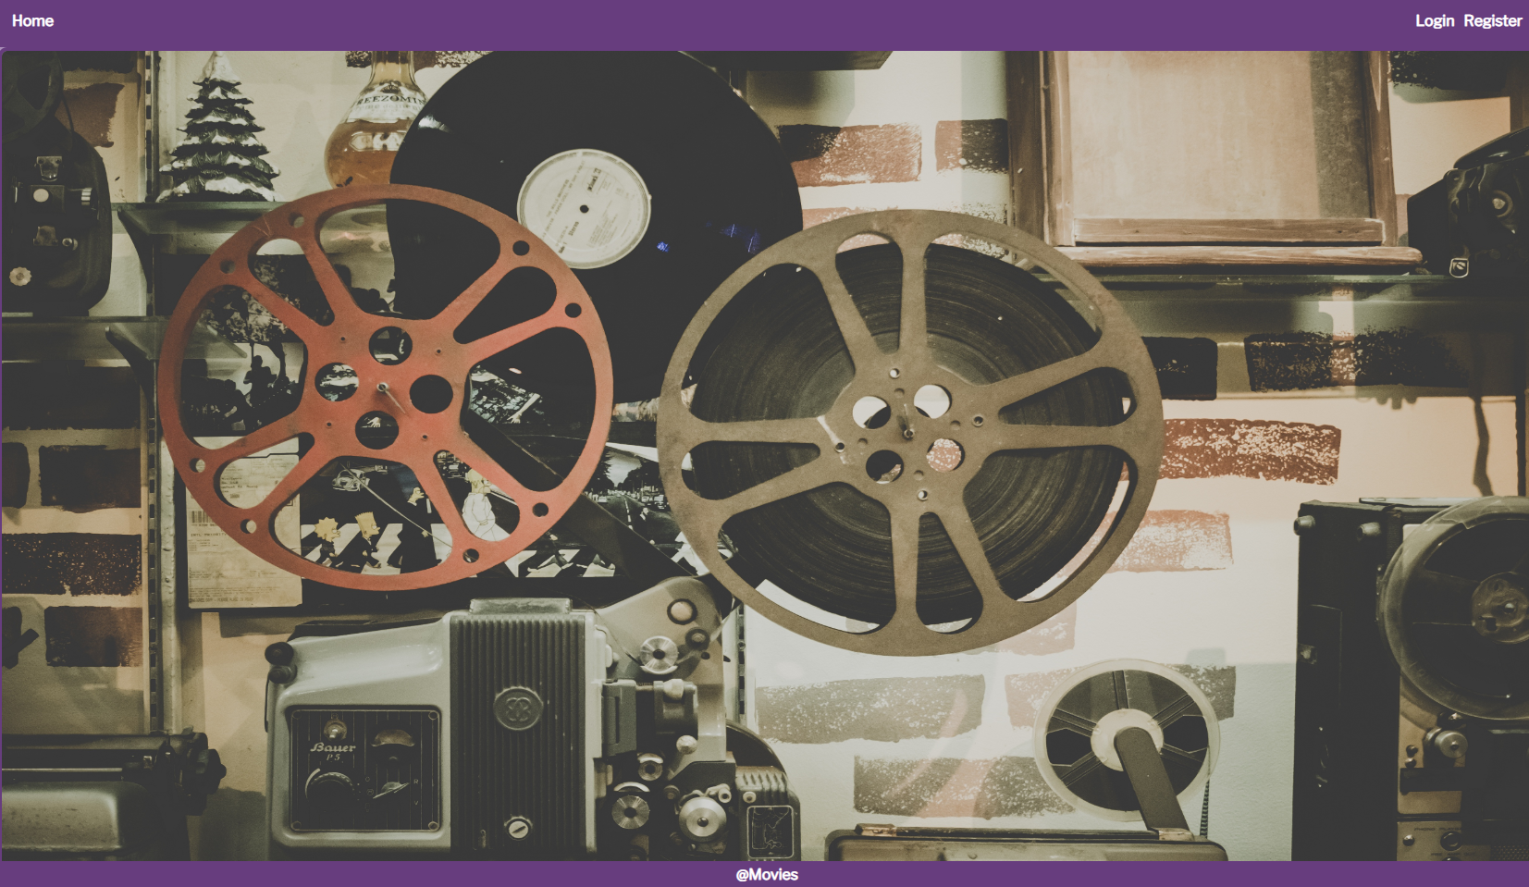

### Register User (5 pts)

By given **username** and **password** the app should register a new user in the system.

* You should make the following validations:
  + The **username** should be **at least 3 characters** long
  + The **password** should be **at least 6 characters** long
  + The **repeat password** should be **equal to the password**
* After a **successful registration**, a notification message **"User** **registration** **successful."** should be **displayed** and the user should be **logged-in**.
  + Home pageshould be **displayed** with the **User navbar**.
* In case of **error** (eg. **duplicate** username, **non-matching** passwords), an appropriate **error** **message** should be **displayed** and the client should be able to **try** to register again.
* Keep the **user session data** in the browser’s **session storage**.

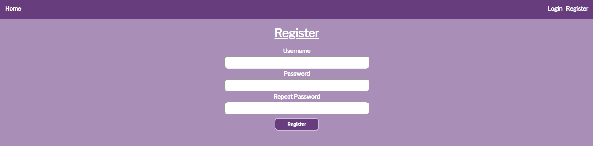

### Login User (5 pts)

By given **username** and **password** the app should be able to login an existing user.

* After a **successful login**, a notification message **"Login** **successful."** should be displayed and the user should be **logged-in**.
  + Home pageshould be **displayed** with the **User navbar**.
* In case of **error**, an appropriate **error message** should be **displayed** and the user should be able to fill the **login form** again.
* Keep the **user session data** in the browser’s **session storage**.

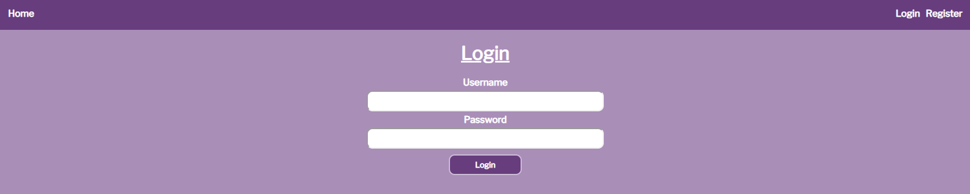

### Logout (5 pts)

Logged-in users should be able to **logout** from the app.

* After a **successful** logout, a **notification** message **"Logout** **successful."** should be displayed and the user should be **logged-out**.
  + Login pageshould be **displayed** with the **user navbar**.
* The **Logout REST service** at the back-end should be obligatory **called** at logout.
* All local information in the browser (**user session data**) about the current user should be **deleted**.

### Cinema (30 pts)

Logged-in users should be able to **view all movies**.

Clicking the [Cinema] **link** in the **NavBar** should **display** the Cinema page.

The Cinema page should **list all** of the **movies**, in a **formatted** and **ordered** manner:

* The **movies** should be listed in the **format** as shown in the web design (see the screenshot below).
* The **movies** must be **sorted** by the **available tickets** in **descending**.
* Each **movie** has **title**, **image, available tickets, buttons:** [Buy Ticket] **and** [Details].

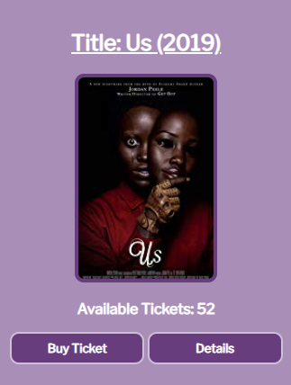

* The **Cinema** page should look like this:

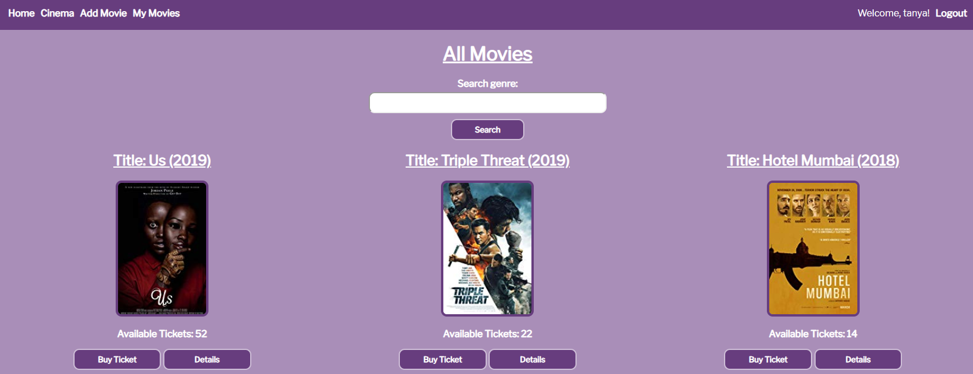

### Add Movie (10 pts)

Logged-in users should be able to **Add** movies.

Clicking the [Add Movie] **link** in the **NavBar** should **display** the Add Movie page.

* The form should contain the following validations:
  + The **title** should be **at least 6 characters** long.
  + The **description** should be **at least 10 characters** long.
  + The **image** should start with **"http://"** or **"https://"**.
  + The **available** **tickets** should be a **number**.
  + The **genres** must be separated by a **single space**.
* After a **successful** **movie** **creation**, a notification message **"Movie** **created** **successfully."** should be **displayed** and the Home pageshould be shown.
* The inputs fields in the form **should be cleared.**
* The newly created movie should be stored in the Kinvey collection "movies".

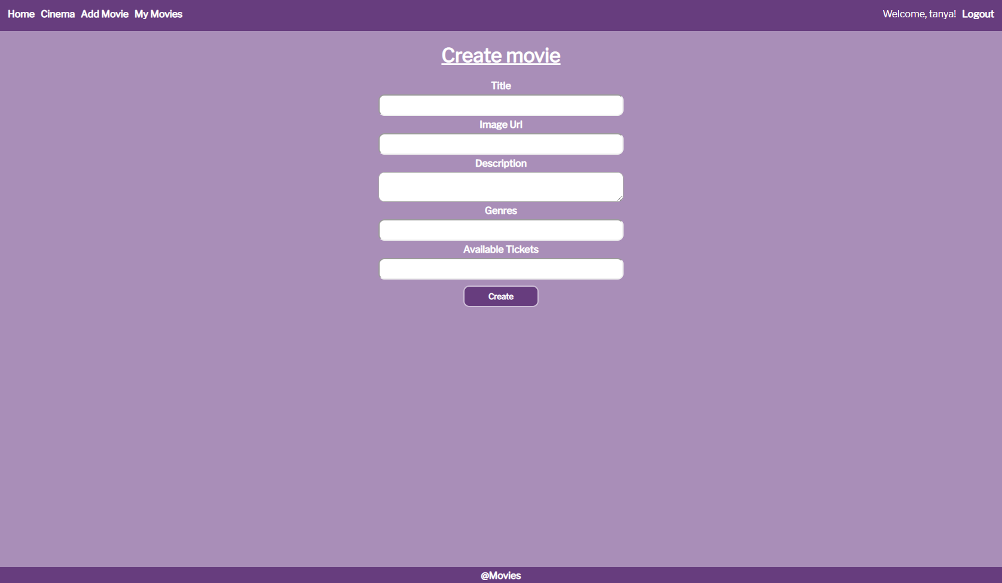

### Buy Ticket (5 pts)

Logged-in users should be able to **Buy tickets** formovies.

Clicking the [Buy Ticket] **link** of a **particular movie** should **decrease** its **available tickets**. If there are **no available tickets**, anappropriate **notification** should be **displayed** and the **available tickets** should **not be changed**.   
Users can **buy multiple tickets** for **one movie.**

* After **successfully buying** a **ticket**, a notification message **"Successfully** **bought** **ticket** **for** **{movie** **name}!"** should be displayed.

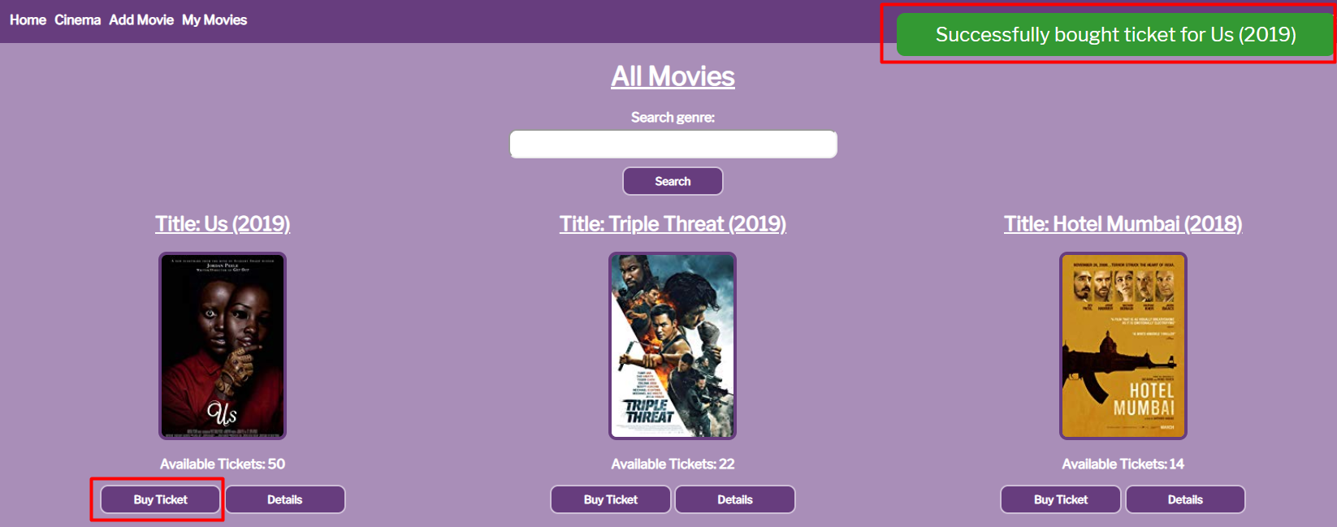

### Movie Details (5 pts)

Logged-in users should be able to **view details** aboutmovies.

Clicking the [Details] **link** in of a **particular movie** should **display** the Movie Details page.

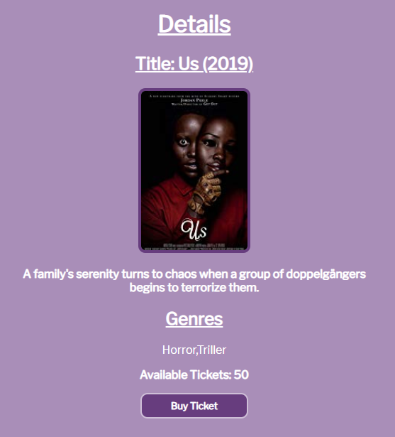

* From this **view**, the user should also be able to **buy tickets** - [Buy Tickets] link.

### My Movies (10 pts)

Logged-in users should be able to **view their** movies.

Clicking the [My Movies] **link** in the **NavBar** should **display** the My Movies page.

* The **movies** should be listed like in the **cinema** section, except theuser should see only the **movies** that he created and each movie should have [Edit]and [Delete] buttons, which will **show** the **corresponding pages**.

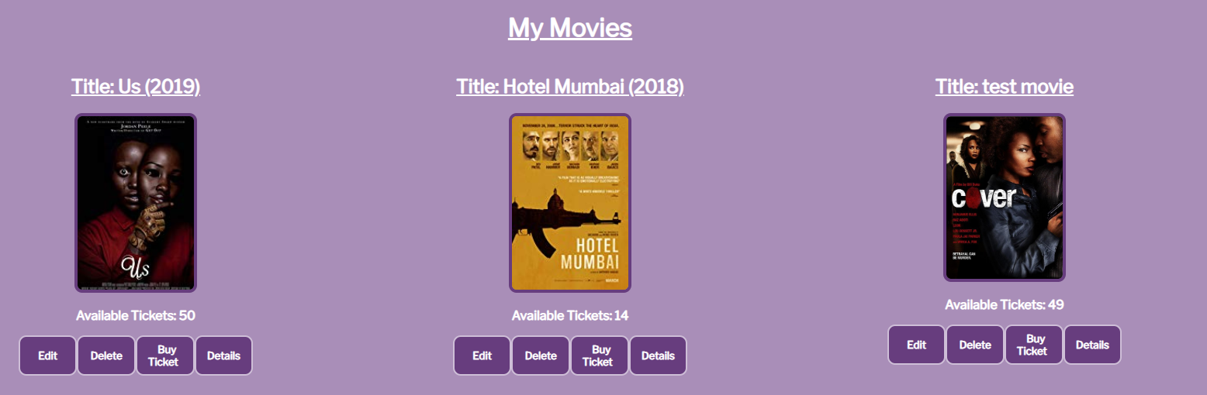

### Edit Movie (5 pts)

Logged-in users should be able to **edit their** movies.

Clicking the [Edit] **link** of a **particular movie** on the My Movies page should **display** the Edit Movie page:

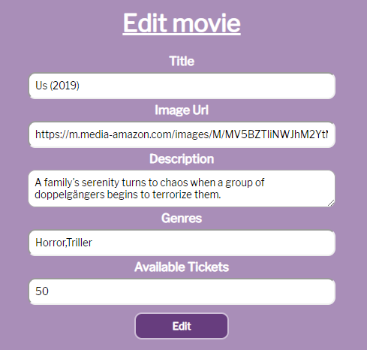

* After a **successful edit**, an appropriate notification should be **displayed**!

### Delete Movie (5 pts)

Logged-in users should be able to **delete their** movies.

Clicking the [Delete] **link** of a **particular movie** on the My Movies page should **display** the Delete Movie page:

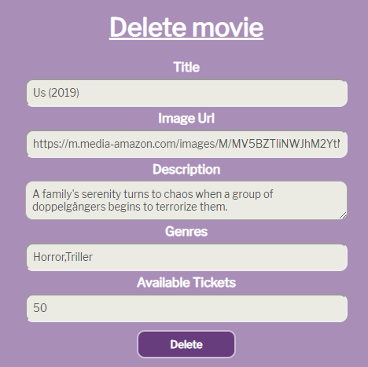

* The **input fields** should be **disabled**.
* After **successful** **movie delete** a notification message **"Movie** **removed** **successfully!"** should be displayed and the Home pageshould be **shown**.

### (BONUS) Search: (5 pts)

Logged-in users should be able to **search** formovies, by typing some **genre** (**case sensitive**) on the **search field** of the Cinema page.

Clicking the [Search] link should **display** the **same view** (Cinema page), but **only** with the **movies** which **contain** the **given genre**:

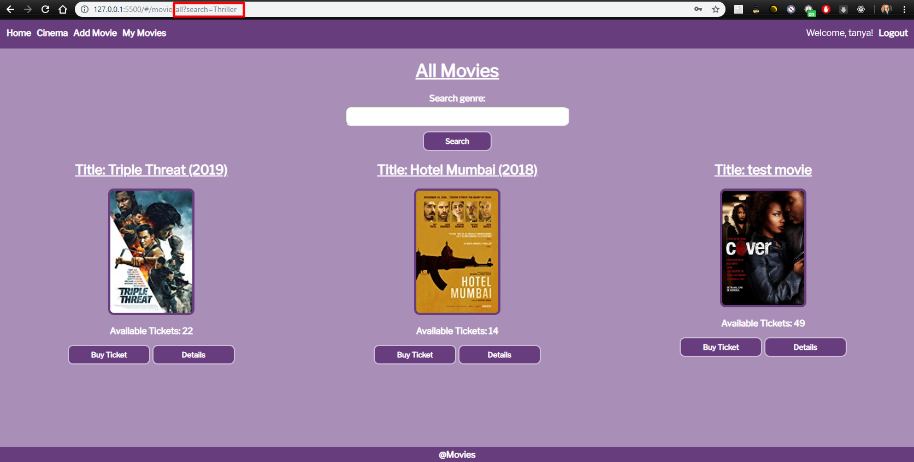

## Submitting Your Solution

Submit a ZIP file with your project folder. Exclude the node_modules folder. Upload the archive to the Judge.